**Ideation phase**

**Define the problem statement**

|  |  |
| --- | --- |
| **Date** | **02/11/2023** |
| **Team Id** | **NM2023TMID11232** |
| **Project name** | **How to create a landing page in hubspot** |
| **Maximum Marks** | **2MARKS** |

**PROPBLEM STATEMENTS:**

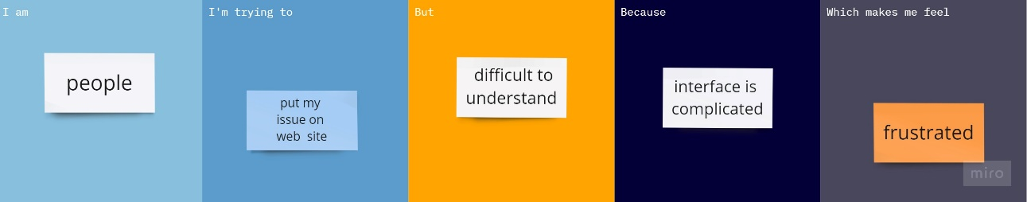

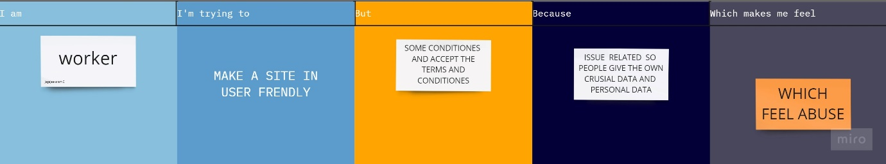

|  |  |  |  |  |  |
| --- | --- | --- | --- | --- | --- |
| **PROPLEM**  **STATEMENT**  **(PS)** | **I AM** | **I AM TRYING TO** | **BUT** | **BECAUSE** | **WHICH MAKE A**  **FEEL** |
| PS -1 | PEOPLE | PUT MY ISSUE ON WEB SITE | DIFFICULT  TO UNDERSTAND | INTERFACE  COMPILCATED | FRUSTATED |

|  |  |  |  |  |  |
| --- | --- | --- | --- | --- | --- |
| **PROPLEM STATEMENT**  **(PS)** | **I AM** | **I AM TRYING TO** | **BUT** | **BECAUSE** | **WHICH**  **MAKE A**  **FEEL** |
| PS-2 | WORKER | MAKE A SITE IN USER  FRIENDLY | ACCEPT THE  TERMS AND CONDITION | PEOPLE GIVE THE OWN DATA CRUSIAL | FEEL ABUSE |